

PVA Productio

Sjoerd Halmans

2021

Inhoud

1. Project assignment 2

1.1 Context 2

1.2 Project goal 2

1.3 boundaries and conditions 2

1.4 Strategy 2

1.5 Research questions 2

1.6 Main questions 3

1.7 Finalized project 3

2. Project organisation 4

2.1 Project members 4

2.2 Communication 4

3. Activities and time plan 5

3.1 Project approach 5

3.2 Time plan 5

4. Test plan and configuration management 5

4.1 Test plan 5

4.2 Configuration management 5

5. Finances and risks 6

5.1 Finances 6

5.2 Risks 6

# 1. Project assignment

## Context

For my 6th semester at Fontys HBO-ICT, I have gotten the assignment to make an enterprise system. This system can do whatever I think would make for a good enterprise software system and allow me to show my teachers I have the ability to create these systems. I have chosen to make an online dashboard for a fictive company.

## Project goal

The goal for this project will be making an online dashboard that will enable the different users of the web application to manage all of their different online needs. An example of this is that a production manager will be able to manage the different production lines within the production department.

The ultimate goal of the application is to combine all the online data into one big dashboard, doing this enables the company to really use the different data numbers from all the different departments to make good executive decisions and make sure less human errors are made.

## 1.3 boundaries and conditions

|  |  |
| --- | --- |
| Part of the project: | Not part of the project: |
| A dashboard allowing multiple different kinds of users to do their online tasks. | Algorithms that replace the employees in their work. |
| A strong architecture with possibility to easily expand it. | Setting up a full infrastructure (think about routers/firewalls) |
| An online dashboard to simulate setting up a production line. | Actually programming production firmware. |

## Strategy

The project will be done by myself, this allows me to decide what strategies I want to use by myself. I am planning on doing a scrum approach. I will be making sprints for myself and setting goals for them, this will allow me to keep my tasks organized and keep track of what I have already finished and still need to take care of. I will be working quite flexible within the project, making changes to old software when needed/possible and testing throughout the entire project instead of just in the final face of the project.

As already discussed with the teachers I will be showing my progress every two weeks at a general meeting with them and my fellow group members. This has made me come to the decision that I will be doing two week sprints.

## Research questions

For this project I have decided to also put in a little bit of research, I quite some things I want to research this semester and will have one main question which I want to answer using the conclusions of all my sub-questions.

This research will also help me make architectural decisions so I will focus on doing part of the research before I do anything else within the project.+

## Main questions

The main question I want to ask and research this semester is as follow :

**“**What is a suitable microservice architecture to make Productio a strong system**”**

While I won’t go further into this in this document. This will be the main focus of my research this semester, and all different sub-questions will server to answer this question. Be it by giving me more insight into the main question or using it’s conclusion to make a better decision.

## Finalized project

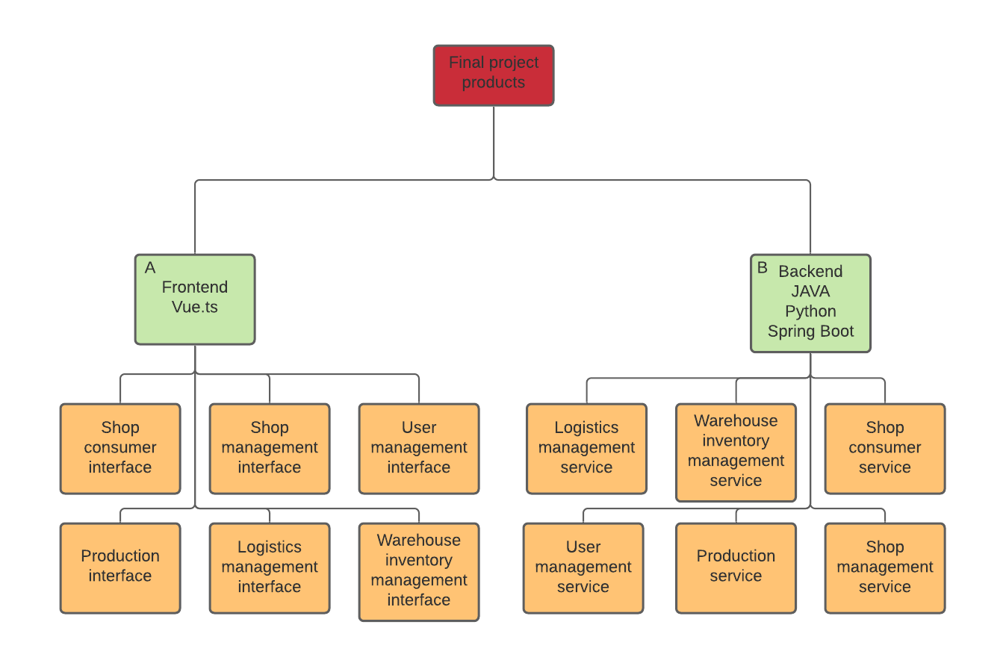

In this diagram I have visualized my first thoughts on what products I want to create this semester, as you can see I have divided them into two different sides, A being the frontend and B being the backend. Both are similar in a way as to what products have to be made, every service will have their own interface in my current plan. (though this might change at some point in the project as I might make additional services that don’t need an interface of their own.)

I am confident that this will make for a good product both for my own growth and as a way to show my teachers that I have grown in my ability to make enterprise software.

# 2. Project organisation

## 2.1 Project members

|  |  |
| --- | --- |
| Name | Role |
| Sjoerd Halmans | Developer/product owner |
| Mario Hendriks | Stakeholder |
| Nicky Janse | Stakeholder |
| Wiebe van Herwijnen | Stakeholder |
| Joost van Herwaarden | Stakeholder |
| Tom van Kaathoven | Stakeholder |
| Marco Halmans | Stakeholder |
| Marcel Veldhuijzen | Teacher/Stakeholder |
| Kiavash Bahreini | Teacher/Stakeholder |

## 2.2 Communication

As discussed previously, my plan is to communicate with my teachers every two weeks via a general meeting. In this meeting I plan to ask for feedback and also see what their thoughts are on the future of my project. The rest of the stakeholders, I will approach at not yet decided times to ask for feedback.

# 3. Activities and time plan

## 3.1 Project approach

My plan is to sit down every Monday and have a look at how the project is doing and what I should do that week. (except if I still have something to do in my sprint planning) My sprints will be quite flexible, I will always attempt to finish what I have scheduled for a sprint. And if I finish early I will pull a few requirements from the next sprint into this one, this might allow me to also implement some could haves if time permits it.

## 3.2 Time plan

|  |  |  |
| --- | --- | --- |
| **Modules** | **Start** | **End** |
| 1 Project setup | Sprint 0 | Sprint 1 |
| 2 Architecture | Sprint 1 - week 1 | Sprint 1 - week 1 |
| 3 Basic login | Sprint 1 - week 2 | Sprint 2 |
| 4 Production | Sprint 2 | Sprint 3 |
| 5 Logistics | Sprint 3 | Sprint 4 |
| 6 Requisitions | Sprint 4 | Sprint 5 |
| 7 HR | Sprint 5 | Sprint 6 |
| 8 Sales | Sprint 6 | Sprint 7 |
| 9 Polishing | Sprint 7 | Sprint 8 |
| 10 Deployment | Sprint 4 | Sprint 9 |
| 11 Testing | Sprint 2 | Sprint 9 |

This is the time plan I have envisioned for this semester, my plan is to stick to this time frame. But there can always be circumstances in which I will have to move a few things around. This will be documented if it were to be the case.

# 4. Test plan and configuration management

## 4.1 Test plan

A lot of the testing done in this project will be done by hand. This means I will create a user account and do QA testing. Apart from that I also plan on making different kinds of code tests (e.g. Unit tests/frontend tests) to assure my code works the way I have intended it as well. The amount of tests written for a part of the system will depend on it’s importance to the overall system.

My initial plan is to set up CI using travis and having this run my tests before a new commit is send towards the GitHub.

To also test my code quality I will be doing frequent tests with SonarQube to unearth any code smells

## 4.2 Configuration management

I will be working with releases within my project. This means that I will be releasing different parts of the system into the GitHub as they are ready for production and bug free. Doing this will allow me to keep the system running at any time instead of having to take down the entire system every time I want to change something in the project.

# 5. Finances and risks

## 5.1 Finances

Financially seen, this project will not be a problem for me. I have enough knowledge and equipment to host the app for free and will not need to purchase any other software to create the product it self if I keep to the current vision I have.

## 5.2 Risks

There is only one risk I see within this project, this would be running out of time. I have put down a big idea and I am confident that I will be able to finish most of it in time for the final evaluation. But the possibility that I will have to scrap some parts of the application are there. This might be a bigger issue than previous semesters seeing as my development is sometimes delayed due to covid-19. Partially due to not having the best working environment and sometimes not being able to contact the people I need for feedback in the timeframe that I would like.

To counter this I will work on the parts of the system that depend on each other. That way, having to scrap a part won’t mean I lose functionality on something I have already made.